**Title of the Project/Invention:** Real Time Based Solider Health Monitoring System Using GPS and GSM

**Names of Project Team Students/Inventors including the Guide’s Name:**

S. Towseef Ahmed

Bandi Muralidhar Reddy

Yelamakuri Nanda Krishna

Kasupogu Raju

**ABSTRACT:**

In today’s world the security of the nation is depends upon the enemies’ warfare and so the safety of the soldiers is considered as vital role in it. A country’s arm forces consist of three professional uniformed services: the army, the navy, and the air force. Concerning the soldier’s safety there are many instruments to view their health status as well as ammunitions on the soldiers. To overcome the safety concern, we had built this method which using wireless body area sensor network such as temperature sensor, heartbeat sensor etc will monitor the health status of the soldier whenever required. Also using GPS, we can track the soldier’s exact location whenever required. These devices are being added to weapons, firearms, and militaries such as the Israeli an Army which are exploring the possibility of embedding GPS devices into soldiers vests and uniforms so that field commanders can track their soldier’s movements in real time GSM module can be used for effective range of high-speed transmission, short range and soldier-to-soldier wireless communications that will be required to relay information on situational awareness, tactical instructions, and covert surveillance related data during special operations reconnaissance and other missions. By using all this equipment’s we had tried to implement the basic guarding system for the soldier in low cost, light weighted, portable and precise device. In today’s world enemy warfare is an important factor in any nation’s security. The important and vital role is played by the army soldier’s. There are many concerns regarding the safety of these soldiers. In our method we have come up with an idea of tracking the soldier as well as to give the health status of the soldier during the war, which enables the army personnel to plan the war strategies. By using the location sent by the GPS modem, the base station can understand the position of soldier.

**DESCRIPTION**

The main intention of this patent is to find out the exact location of the injured solider in the war field. This GSM based solider health and position tracking system retrieves the exact location of a soldier in terms of its longitude and latitude. This data is fed to the Arduino, which is interfaced to a GSM modem. The Arduino retrieves the exact location details from the GPS and sends an SMS to the concerned authority over GSM modem. An LCD display is connected to the Arduino for crossing the data received before being sent over GSM. This method will be very useful to army base station to keep track of their soldiers.

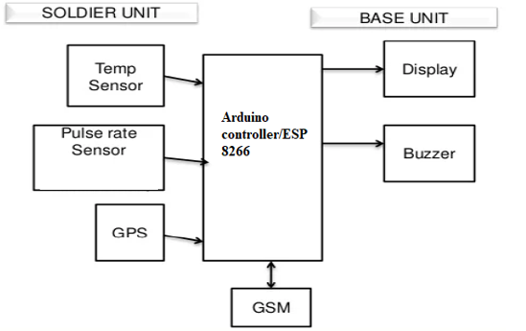

Fig.1. Block Diagram

* Soldier's Health Monitoring Device: Each soldier is equipped with a wearable device that integrates various sensors and To monitors vital indications such as heart rate, body temperature, blood pressure. The device is also equipped with a GPS module to determine the soldier's location.
* Data Collection: The Health monitoring device continuously collects the soldier's vital signs and GPS coordinates. It stores this information in its internal memory for further processing.
* Data Transmission via GSM: At regular intervals or in real-time, the device establishes a connection with the GSM network. It uses the GSM module to transmit the collected data to a central server.
* Central Server: The central server receives the transmitted data from multiple soldiers. It acts as a central hub for processing and analyzing the received information.
* Data Processing and Analysis: The server employs sophisticated algorithms to process and analyze the received data. It identifies any abnormal readings or potential health risks based on predefined thresholds and medical guidelines.
* Alert Generation: If the server detects any critical health issues or anomalies, it generates an alert. This alert is sent to authorized personnel, such as medical professionals or commanding officers, through various means like text messages, emails, or notifications on dedicated applications.
* Visualization and Monitoring: The server provides a user-friendly interface that displays real-time health status and location information of individual soldiers. This allows authorized personnel to monitor the soldiers' well-being and make informed decisions.
* Emergency Response: In case of emergencies or critical health situations, the system triggers an immediate response. This can involve dispatching medical teams to the soldier's location or providing necessary instructions to the soldier or nearby personnel.

**EXPERIMENTAL SETUP:**

The system starts with wearable health sensors attached to each soldier. These sensors continuously measure vital indicators including heart rate, body temperature, and activity levels. Linked to every soldier, the GPS module monitors and logs the exact whereabouts of each individual soldier in real-time. The GPS data is a crucial aspect of the monitoring system, providing dynamic positioning information. The health sensors and GPS modules are linked to GSM communication modules.

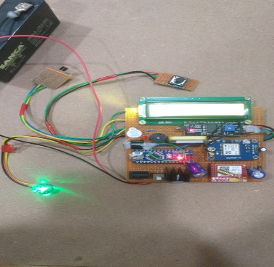

Fig.2. Hardware Kit

These modules enable wireless communication and data transmission using the GSM network. The GSM network facilitates communication with a mobile application on each soldier's device. The application serves as an interface, allowing soldiers to view their real-time health status and receive immediate feedback. The GSM network connects the soldier's wearable sensors, GPS modules, and mobile applications to a centralized command and control center

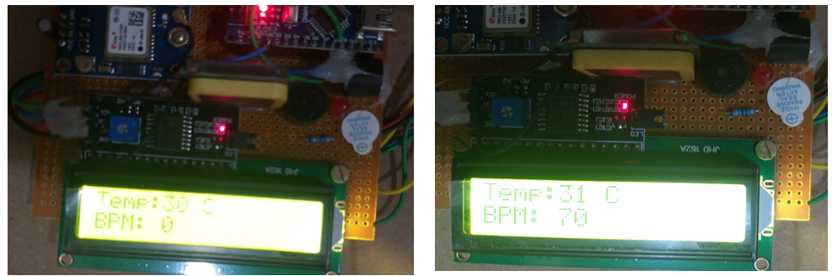

Fig.3. Displaying Various Results

This central hub acts as a receiver for all incoming data from the soldiers in the field. The centralized command centre is linked to a backend server. The server manages the storage, processing, and analysis of the incoming health and location data from all soldiers. Visualization tools are connected to the backend server, presenting processed data in an understandable format. Commanders can check the health and locations of soldiers through these tools. An alert system is integrated into the backend server. In the event of emergencies or abnormal health conditions, the system triggers alerts to notify commanders for immediate attention.

The final result is as follows: A confirmation message, verifying GSM and GPS settings, is sent to the designated phone number. Subsequently, if there is a deviation in the standard bodily parameters, an alert message, along with the soldier's exact location, is sent to the central base station.

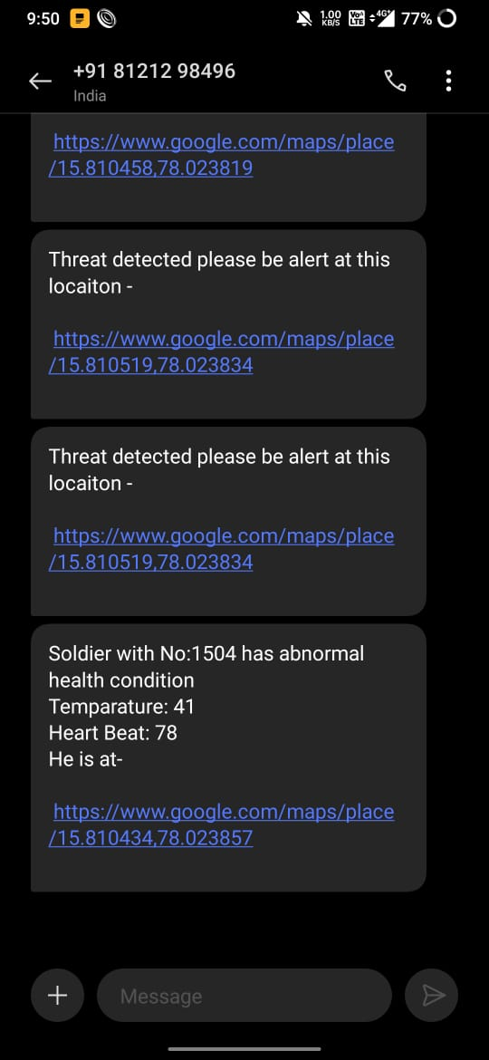

Fig.4. Displaying final output in mobile through text message

Hence, the idea of tracking and navigation devices holds immense value for soldiers in the midst of wartime combat and for base stations. This enables them to obtain real-time updates on the positions of soldiers.

**Advantages:**

1. No need to go on field.
2. Higher reliabilty.
3. Cost effective.
4. Fast and efficient

**Applications:**

1. Soldier health monitoring in real-time via GPS/GSM.
2. Real-time tracking of soldier health utilizing GPS/GSM.
3. GPS/GSM-enabled system for soldier health monitoring in real-time.
4. Monitoring soldier health in real-time with GPS/GSM technology.
5. Real-time soldier health tracking system powered by GPS/GSM.

**REFERENCES:**

1. Hock Beng Lim, Di Ma, Bang Wang, Zbigniew Kalbarczyk, Ravishankar K. Iyer, Kenneth L. Watkin (2010) “A Soldier Health Monitoring System for Military Applications” International Conference on Body Sensor Networks, pp: (246-249).
2. William Walker, A. L. Praveen Aroul, Dinesh Bhatia (2009) “Mobile Health Monitoring Systems” 31st Annual International Conference of the IEEE EMBS, Minneapolis, Minnesota, USA, pp: (5199-5202).
3. M. Pranav Sailesh, C. Vimal Kumar, B. Cecil, B. M. Mangal Deep, P. Sivraj (2014) “Smart Soldier Assistance using WSN” International Conference on Embedded Systems - (ICES 2014), IEEE, pp: (244-249).
4. P.S. Kurhe, S.S. Agrawal (2013) “Real Time Tracking and Health Monitoring System of Remote Soldier Using ARM 7”, International Journal of Engineering Trends and Technology, 4(3), pp: (311-315).
5. Shruti Nikam, Supriya Patil, Prajkta Powar, V. S. Bendre (2013) “GPS Based Soldier Tracking and Health Indication System” International Journal of Advanced Research in Electrical, Electronics and Instrumentation Engineering, 2(3), pp: (1082-1088).
6. Prof. Pravin Wararkar, Sawan Mahajan, Ashu Mahajan, Arijit Banerjee, Anchal Madankar, Ashish Sontakke (2013) “Soldier Tracking and Health Monitoring System” The International Journal of Computer Science & Applications, 2(02), pp: (81-86).
7. Govindaraj A., Dr. S. Sindhuja Banu (2013) “GPS Based Soldier Tracking and Health Indication System with Environmental Analysis”, International Journal of Enhanced Research in Science Technology & Engineering, 2(12), pp: (46-52).
8. Palve Pramod, “GPS Based Advanced Soldier Tracking With Emergency Messages & Communication System” (2014) International Journal of Advance Research in Computer Science and Management Studies, 2(6), pp: (25-32).
9. Mr. Rajdeep Limbu, Prof. V. V. Kale (2014) “GPS Based Soldier Tracking and Health Monitoring System” International Journal for Technological Research in Engineering, 1(12), pp: (1485- 1488).
10. K.C.T. Swamy, D. Venkata Ratnam and Towseef Ahmed Shaik, "Double difference method with zero and short base length carrier phase measurements for Navigation with Indian Constellation satellites L5 (1176.45 MHz) signal quality analysis", Int. J. Satell. Commun. Networking, vol. 40, no. 4, pp. 294-304, 2022.
11. Simon L. Cotton and William G. Scanlon ―Millimeter - wave Soldier –to soldier communications for covert battlefield operations Defence science and technology laboratory, IEEE communication Magzin October 2009.
12. Hock Beng Lim “A Soldier Health Monitoring System for Military Applications‖ 2010 International Conference on Body Sensor Networks (BSN).
13. JouniRantakoko,JoakimRydell and peter Stromback,‖Accurate and Realiable soldier and first responder Poasitioning :Multisensor System and co-operative localization‖April-2011.
14. K.C.T Swamy, A. D Sarma, A Supraja Reddy, Analysis of Ionosphere scintillation of GPS and VHF/UHF signals over low latitude Indian region, Information and communi-cation Technologies (WICT), 2012 World Congress, IEEE, 2012.
15. Vincent Pereira, Audrey Giremus,andericgrivel ―Modeling of the multipath environment using copulas For particle filtering based GPS navigation‖ June-2012.
16. M.V.N.R. Pavan Kumar1, Ghadge Rasika Vijay2, PatilVidya Adhikrao3, Bobade Sonali Vijaykumar4 Department of Electronics and Telecommunication Engineering 1,2,3,4, LNBCIET, Satara-415020 1,2,3,4Health Monitoring and Tracking of Soldier Using GPS.
17. Arya V Nair, Rani Raju, Tinsa Elsa Thomas and Vidya R Nair, “IoT Based Soldier Monitoring System”, Pramana Research Journal, Volume No:9, Issue:5, pp: 157-165,2019.
18. Brijesh Iyer and Niket Patil, “IoT enabled tracking and monitoring sensor for military applications”, International Journal of Systems Assurance Engineering and Management, SPRINGER, July-2018.
19. D. Poornakumar, R. Periyanayaki, M. R. Pradheepa, N. Prakashkumar, and S. Nandhini, “Soldiers Navigation and Health Monitoring System using GPS and GSM”, International Journal of Research in Engineering Science and Management, Volume No: 3, Issue:4,pp:115-158, April-2020.
20. Deepa J, Ranjini, Sharanya Raj and Dr.Parameshachari B D, “Soldier Health Positioning Tracking System Using GPS and GSM Modem”, International Journal of Engineering Research& Technology (IJERT),pp:1-6,2018.